Problem Definition:

This program is designed as a snake game. The user has to enter a name before they start playing so it can be added to the high scores box. The only characters that are allowed are letters and backspace. The cursor is automatically set at the text box, and when you press enter the program automatically performs the “Play” button click. You can exit the menu screen by pressing “Exit”. The “Instructions” button will display a message box telling the user about the game and how to play it. Once the user presses play, the menu form disappears, and the game form appears. In that form, the player presses space bar to start playing. You can leave the game at any given time by pressing the escape button. You can pause the game with P and resume it with R. To play, one must use the up, down, left, and right keys on the keyboard. If the snake hits the wall, or itself it dies and the game ends, the score is added to the high scores list. For every 100 points the player gets, they move up a level.

General Specifications:

General Information:
Application Name: Snake Game
Date Created: June/ 2011
Programmer: Batoul Farhat

List of Filenames:
Storage Location: h:\FinalGame\SnakeGame
Project File: SnakeGame
Form 1: Game.cs

Menu.cs

Control Object type | Property | New Setting | Purpose
Form | Text | Menu | Main form  Menu Form
Form | Name | Menu | Main form  Menu Form
Button | Text | Play | Plays game. Hides this form and opens another
Button | Name | btnPlay | Displays message box explaining how to play
Button | Text | Insrtuctions | Displays message box explaining how to play
Button | Name | btnHelp | Closes application
Button | Text | Exit | Closes application
Label | Name | btnExit | Label for name
Label | Text | Name | Label for name
Textbox | Name | labelName | For player to type name in
Textbox | Multiline | False | For player to type name in
Label | Name | txtName | Label for high scores
Label | Text | High Scores | Label for high scores
Textbox | Name | lableScore | Displays all scores
Textbox | Multiline | True | Displays all scores
 | Name | txtHighScores

Game.cs

Control Object type | Property | New Setting | Purpose
Form | Text | Menu | Game Form.  Where game is played.
Form | Name | Menu | Game Form.  Where game is played.
Media Player | Name | wmd | Plays background music
Progress Bar | Min/max | 0-100 | Fills to indicate level progress
Progress Bar | Name | progressBar | Fills to indicate level progress
Status Strip | Back Color | Transparent | Displays current score and level
Status Strip | Render Mode | Professional | Displays current score and level
Label | Text | Press spacebar | Tells the player the status of the game
Label | Name | spaceBarLabel | Tells the player the status of the game
Timer | Interval | 100 | Speed of snake

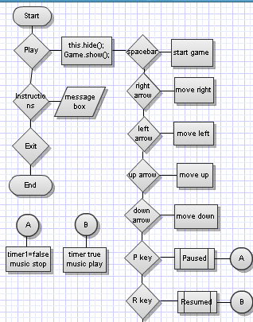
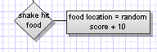
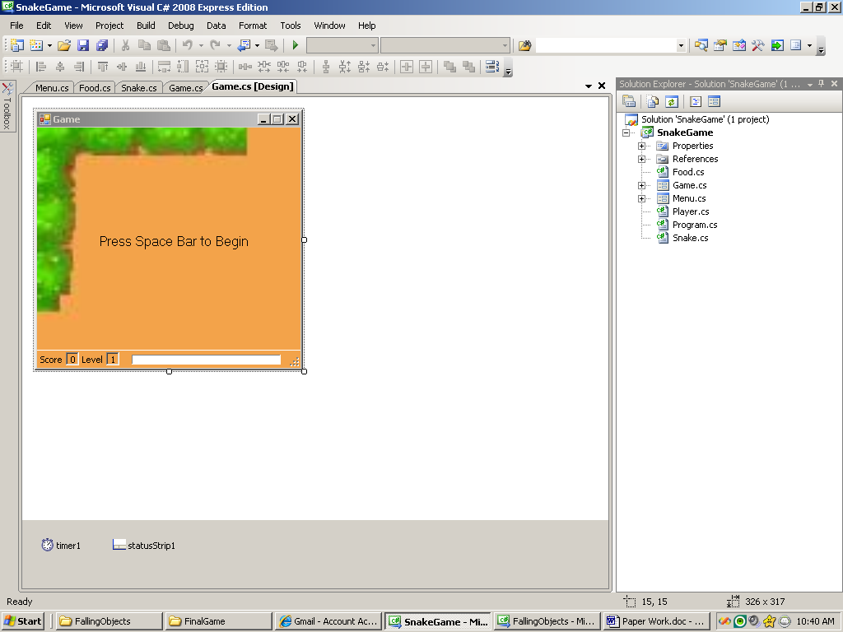
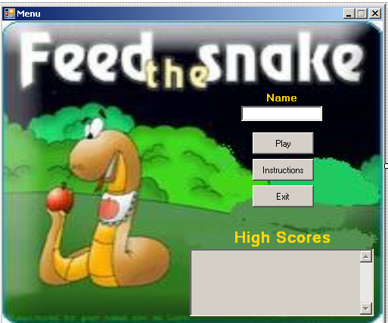
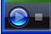
spacebarLabel
toolStripStatusLabel1
toolStripStatusLabel2

Game.cs
progresBar
snakeScoreLabel
snakeLevelLabel
Timer1
statusStrip1

Menu.cs
txtName
btnPlay
btnHelp
btnExit
lableScore
txtHighScores

labelName
wmd

